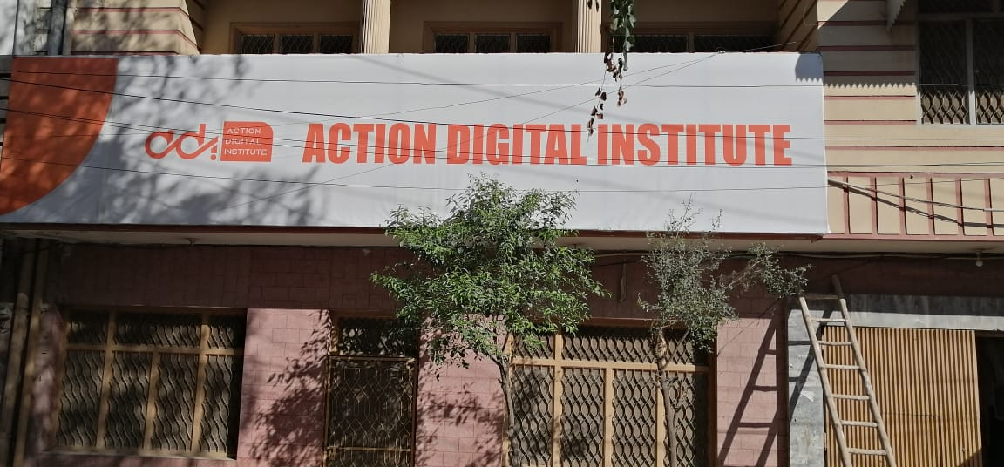


BUSINESS PROFILE
SOFTWARE SOLUTIONS & MARKETING SERVICES PROVIDER

Action Digital Institute (ADI) is a leading provider of Software Solutions and marketing services, committed to empowering businesses and individuals to thrive in the digital age. Our mission is to bridge the digital divide by equipping our clients with the essential skills and tools they need to succeed in a rapidly evolving digital landscape
adi - Peshawar
Coord_adi@outlook.com
Empowering Businesses and Individuals with Digital Skills and Marketing Expertise

Vision Statement:
Empower individuals & businesses inclusively especially women entrepreneurs through transformative IT & AI skills, transcending barriers to poverty, contribute meaningfully to communities, economy and emerge as visionary business leaders of the digital age.

Mission Statement
Our mission is to provide inclusive, comprehensive and transformative IT skills training to individuals, empowering them to overcome poverty, initiate and excel in business ventures, and contribute meaningfully to the society.

Through our innovative programs, we aim to cultivate inclusive business leadership, fostering a diverse and thriving entrepreneurial ecosystem that drives sustainable socio-economic development.

To empower startups, small, and medium businesses nationwide, we aim to provide strategic technical guidance and leverage social media & cutting-edge marketing techniques to accelerate economic growth in the country.

Our Services
Empower Individuals: Provide comprehensive digital skills training to individuals, helping them enhance their employability and entrepreneurial capabilities.

Support Businesses: Offer cutting-edge digital marketing services to businesses, enabling them to reach their target audiences effectively and grow their market presence.

Promote Innovation: Foster a culture of innovation and continuous learning to keep pace with the ever-changing digital environment.

ACTION DIGITAL CONSITS OF THE FOLLOWING DEPARTMENTS

MARKETING DEPARTMENT

SOFT- SOLUTIONS DEPARTMENT

EDITING DEPARTMENT

ACADEMIC DEPARTMENT

SECTIONS IN DEPARTMENTS -----

- DIGITAL MARKETING
MARKETING DEPARTMENT
DEPARTMENT
- ADVERTISING
- PUBLICITY
- PROMOTION
SOFT~SOLE DEPARTMETN
DEPARTMENT

- WEB DEVELOPMENT
- SOFTWARE DEVELOPMENT
APP DEVELOPMENT

- 3D ANIMATION
EDITING DEPARTMETN
DEPARTMENT
- VIDEO EDITING
- GRAPHIC DESIGNING
- AUDIO EDITING
- VOICE OVER

Marketing Services
Our marketing services help businesses enhance their online presence and achieve their marketing goals:

- Digital Marketing Strategy
- Search Engine Optimization (SEO)
- Social Media Management
- Content Marketing
- Pay-Per-Click (PPC) Advertising
- Email Marketing
- Physical marketing through hoarding, SMDs, newspapers, steamers, etc.

Software Solutions:
This is the third thriving department of ADI which encompasses Software development, mobile application development and website designing and development.
- Web Design and Development
- AI/Python Programing
- Software Development

IT Skills Training
We offer a wide range of training programs designed to equip individuals with the skills needed to succeed in the digital economy. Our training programs include:

- Digital Marketing: - Comprehensive courses covering social media marketing, search engine optimization (SEO), email marketing, and more.
- Graphic Design and Multimedia: - Courses in graphic design, video editing, and multimedia production.
- Artificial Intelligence (AI): - Training on content creation through A generating appropriate prompts for marketing of products and services. data analysis tools, business intelligence software, and data-driven decision-making.
- Video Editing: This comprehensive course includes full-fledged training on video and audio editing.
- Social Media Management: This very important component of the overall course which helps students to earn online instantly. We have many success stories on this.
- E-Commerce: This is also a very important tool to business and earn online. Selling product or helping businesses to sell on line, this is also one of the best sources of income for our students who have long term plan for business.
- Freelancing: Selling skills or services online is called freelancing. Students who get trained on freelancing can work independently and earn better.
- You Tube Channel Management: This is also one of the major income sources for students who are trained well on you tube channel management.
- Web Development & Designing: The most prevalent and significant sources of income for startups and individuals include software solutions, mobile application development, and web design. These ventures not only generate substantial revenue but also attract income from international clients, contributing to the country's foreign exchange reserves.

In total 10 plus skills are being provided to our students along with specialization in 1 specific skill. That is complemented by a 1-month incubation support where students work on ADI clients marketing practically and earn money from their marketing services during incubation.

AI/ Development
Training
Marketing
Action Digital Institute
Web Development
Artificial Intelligence
Software Development
Social Media Marketing
Editing
Out Door Advertising
Content Creation
Digital Marketing

Our Approach

Client-Centric: Prioritizing the needs and goals of our clients to deliver tailored solutions that drive results and create value.
Innovative and Adaptive: Staying ahead of industry trends and continuously updating our training programs and marketing strategies.
Experienced Team: Our team of experts ensures the highest quality of service delivery with extensive experience and expertise.
Collaborative Partnerships: Collaborating with industry leaders, educational institutions, and community organizations to amplify our impact.

Why Choose ADI?

- Proven Track Record: Successful track record of delivering impactful training
programs and marketing campaigns.
- Comprehensive Services: End-to-end solutions covering all aspects of digital skills and
marketing.
- Customized Solutions: Tailored approaches that meet the unique needs of each client.
- Continuous Support: Ongoing support and guidance to ensure sustained success
Success Stories


ACTION DIGITAL

CONTACT PERSON
JEHANGIR KHAN- MANAGING DIRECTOR
CELL: 0092 321 9198 214
PHONE & FAX: 0092 91 2040 163
EMAIL: MD_ADI@OUTLOOK.COM, PM_ADI@OUTLOOK.COM
ADDRESS: HOUSE 98F, ZARYAB COLONY, FAQIRABAD NO 2, PESHAWAR,
KHYBER PAKHTUNKHWA, PAKISTAN

